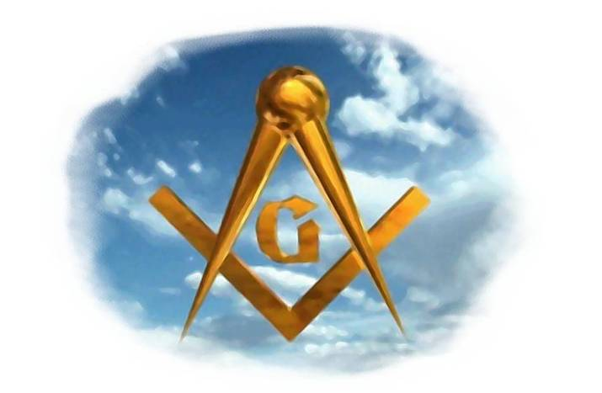
Orator’s Report
on the 18th Degree
Knight Rose Croix
April 18, 2021
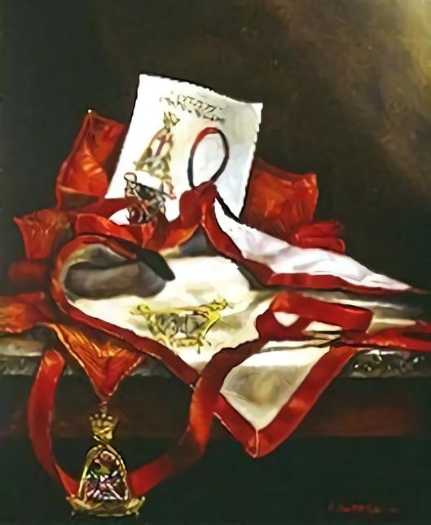

The apron of the 18th Degree is white, bordered in crimson. On the body of the apron is embroidered the jewel of the Chamber of Light.

Bremerton Valley of the Scottish Rite

The Legend: The 15th and 16th degrees deal with the Second Temple of Jerusalem, built by the Jews returning from the Babylonian captivity. The 17th deals with the last book of the New Testament, the Revelation to St. John the Evangelist.
In the final degree of the Chapter of Rose Croix, the 18th - the novice is still in search of truth and the lost word. He is taught that the three “constellations” Faith, Hope and Charity are the three virtues which will guide him on his journey.
The Setting: The Brethren meet in the rubble of a destroyed temple. The Candidate and his escort travel for three days in seek of the lost word finally arriving at the Rose Croix Chamber of the New Temple.
The Ritual: The candidate is led through three apartments. The first describes the world in chaos under the tyranny of evil. The candidate enters this apartment lost in the mists of darkness, error and false philosophy - confused among the ruins of the old system of thought. In the world represented in this apartment, Man has made not only God, but also the devil, in his own image.
The candidate discovers three “constellations” Faith, Hope and Charity to guide him towards the exit from the rudeness of doubt, fainting and despair.
In the second apartment the punishments and terrors of Hell, are described and remind the candidate of the Law of cause and effect.
The search continues both for the True Word and for the explanation of the great enigma of the Universe; that is, how to reconcile the existence of sin and wrongdoing, and the pain and suffering of the world, the prosperity of the fortunate and powerful, the unspeakable injustices and deceptions, the emptiness and superficiality of some religious creeds.
The third apartment represents the universe that shines with the true light of the Supreme Deity and free from the principle of evil. In this chamber the instruction provides various interpretations for the existence of evil that have been created by philosophers and theologians of the past.
The Lecture: The Lost Word is representative of many things - the loss of reason, intellect, and moral sense and the loss of a true conception of deity. During the search, we learn the Masonic meaning of the initials INRI on the Cross of Christ. Note that science is not the enemy of religion but rather the highest expression of it, knowing and understanding the mysteries of God's Universe. It is important to remember that not all the great mysteries have been satisfactorily solved by man's searches; and the existence of evil is one such mystery. When revisiting this Degree, one should pay particular attention to these interpretations, so that each one can find within them a meaning more closely aligned with his own beliefs.
All men are our brothers, whose desires we must satisfy, their opinions to tolerate, their offenses to forgive; that man has an immortal soul, a free will, a right to freedom of thought and action; that all men are equal in the sight of God; that we serve God better by humility, meekness, kindness, and the other virtues that both the poor and the rich can practice.
The mandatory instructions for this Degree are Faith, Hope and Charity. Allied to these virtues is tolerance.
Tolerance: No Mason has the right to measure by another, within the walls of a Masonic temple, the Degree of veneration that he feels for any Reformer, or founder of any religion.
Faith: as Pike says: “Exalting and magnifying faith as we will, and saying that it begins where Reason ends, must after all have a foundation, either in Reason, Analogy, Conscience or human testimony”.
Hope: Only those who are strong are hopeful.
Charity: Only he who judges others charitably is wise.
Faith, hope and charity: Working with Faith, Hope and Charity as our armor, we will wait patiently for the final triumph of good and the complete manifestation of the word of God.

THE MORAL TEACHING: In this degree, Masonry says the Law of Love redefines life and our responsibilities to others.
DUTIES: Practice virtue as this can produce fruit. Work to eliminate vice, purify humanity. Be tolerant of the faith and beliefs of others mistakes and faults of others.
LESSONS: We must have faith in God, humanity, and ourselves.
We must have confidence in victory over evil, the advancement of humanity and the future. Charity is satisfying desires and tolerating the errors of others.
FOR REFLECTION: Are there evil and calamity to give an opportunity to practice virtue? Do your attitudes and actions reflect Faith, Hope and Charity?
IMPORTANT SYMBOLS: The constellations called Faith, Hope and Charity, the punishments and terrors of Hell, the rose, the cross, the pelican and the eagle.
The Apron and Jewel have two sides: The cross on the Chamber of Darkness side of the jewel can be taken to represent the world in suffering when the Word was lost. Resting on the apron of the Chamber of Light side is the nest of a Pelican, containing seven hatchlings. Perched on the edge of the nest is the pelican, piercing her breast with her beak. It was anciently believed that the pelican tore her breast to nourish her young with her own blood. Thus the pelican became a symbol of self-sacrifice, philanthropy, and devotedness.
The Eagle symbolizes Supreme Wisdom and Intelligence.
The Cross is an ancient symbol of infinity and has been used as a sacred symbol to represent the condition of the world. It also has ancient associations with suffering and sacrifice.
The Rose has ancient associations with dawn, and thus with hope and a new awakening to life.
The Cross with Rose on the Chamber of Light side of the jewel represents immortality won by suffering and sorrow.

Adapted from the Spanish version of Rex R. Hutchen’s book A Bridge to Light

